Tan Fern Yee

P20011944

1. As a student, I want to create new post for questions so I can get programming help.

1. As a student, I want to reply to questions so I can share my knowledge with other people.

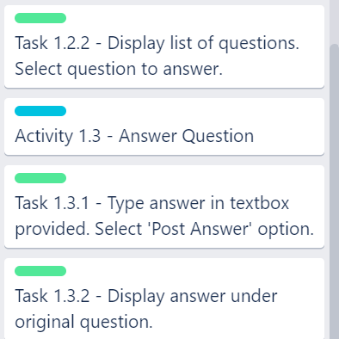

1. As a student, I want to filter questions by tags so I can find specific questions faster.

1. As a student, I want to upvote a useful answer so more people can find this answer.

